**Appendix C: Poster and Flyer**

Poster

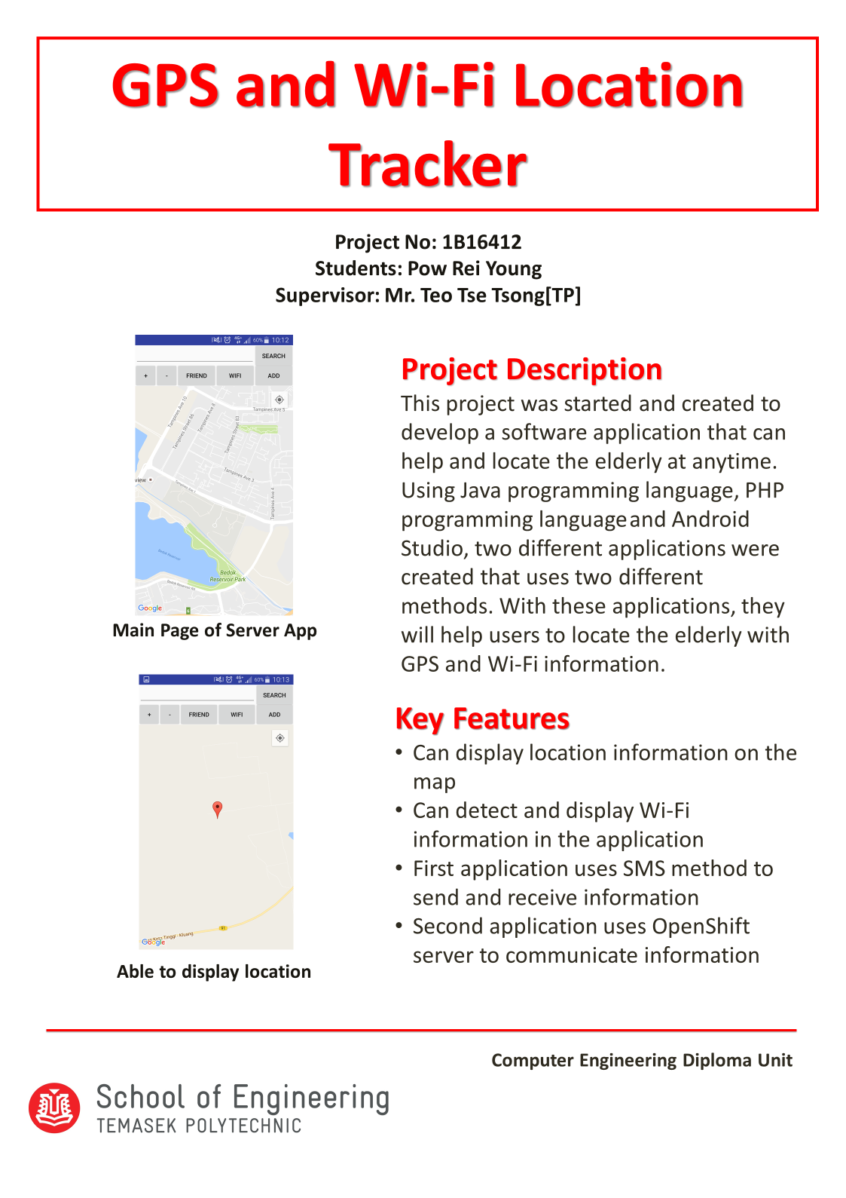

Flyer

